**1.**

**ERD:**

**iii) A paragraph or two (NO MORE) of prose explaining all the changes you made to your ERD and why.**

* I removed the bridge table and I removed PK/FK designations.
* I decided to change from disjoint sub tables to overlapping since hybrid was basically a mix of electric and gas.
* I made some name changes to relationships. This is more intuitive now.
* I have decided to keep postal just because this attribute will be useful as it saves me from using too many joins.

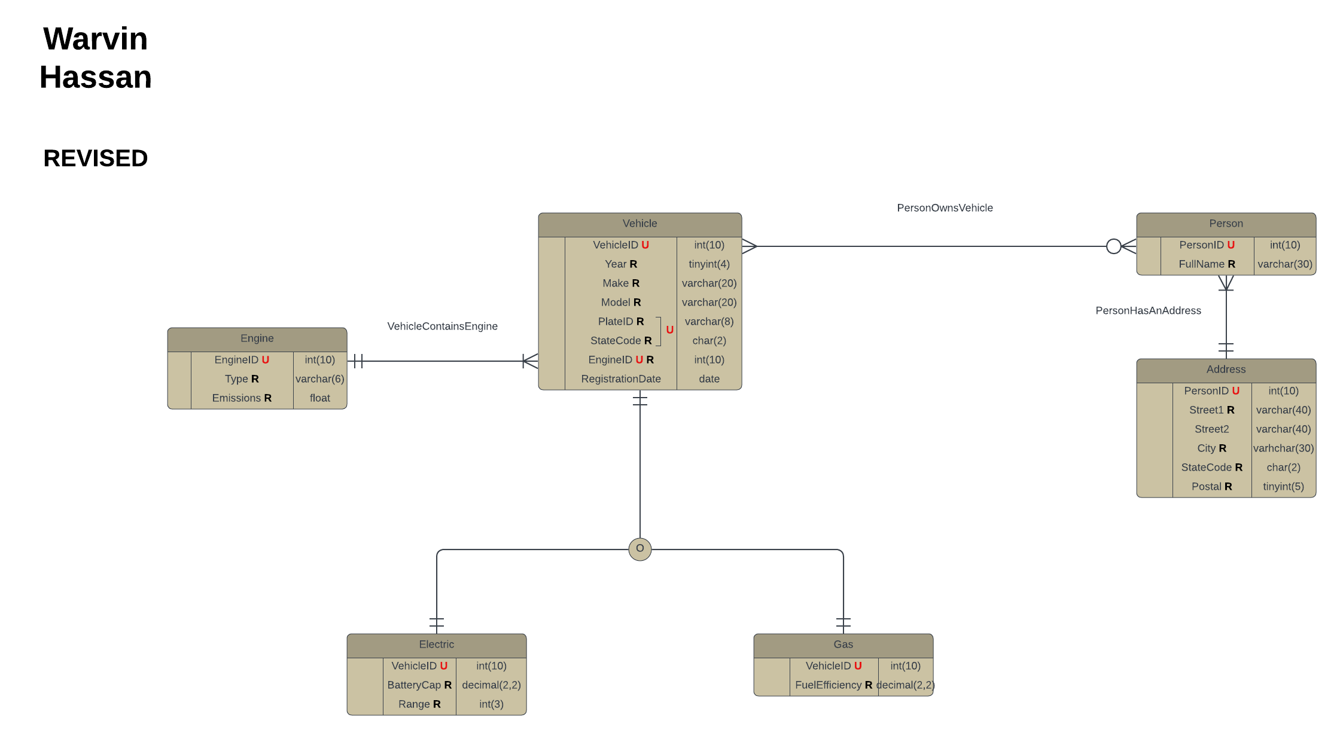

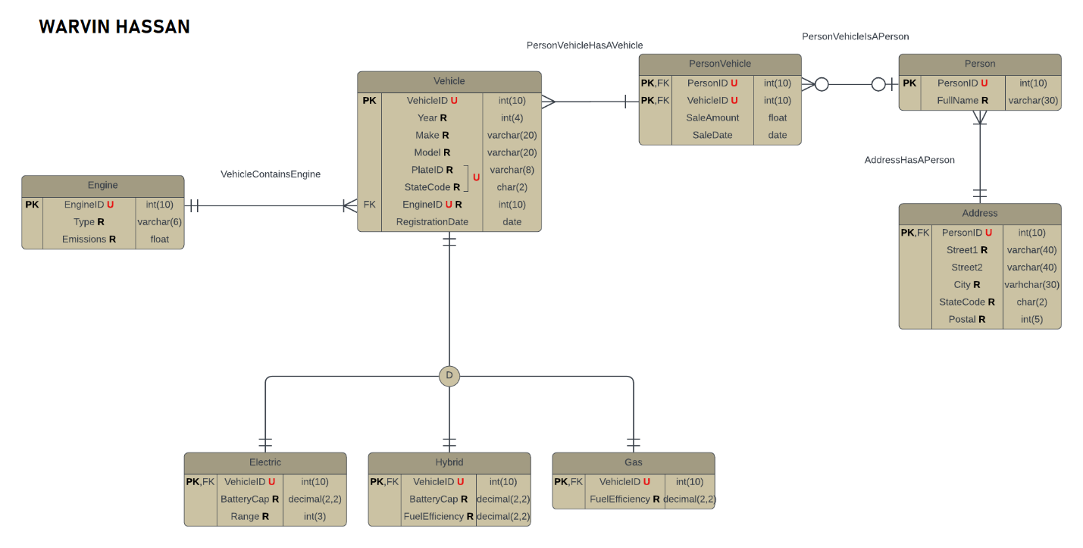

**TABLE:**

**iii) A paragraph or two (NO MORE) of prose explaining all the changes you made to your table diagram and why.**

* I renamed some relationships. The previous ones were weird and less intuitive.
* Changed to overlapping instead of disjoint. Hybrid was unnecessary.

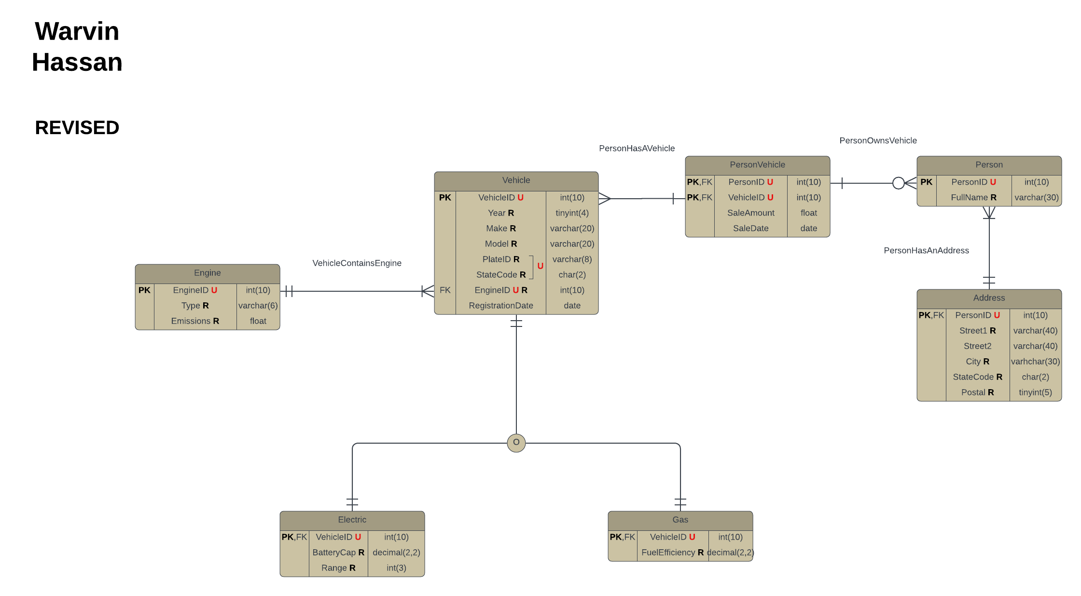

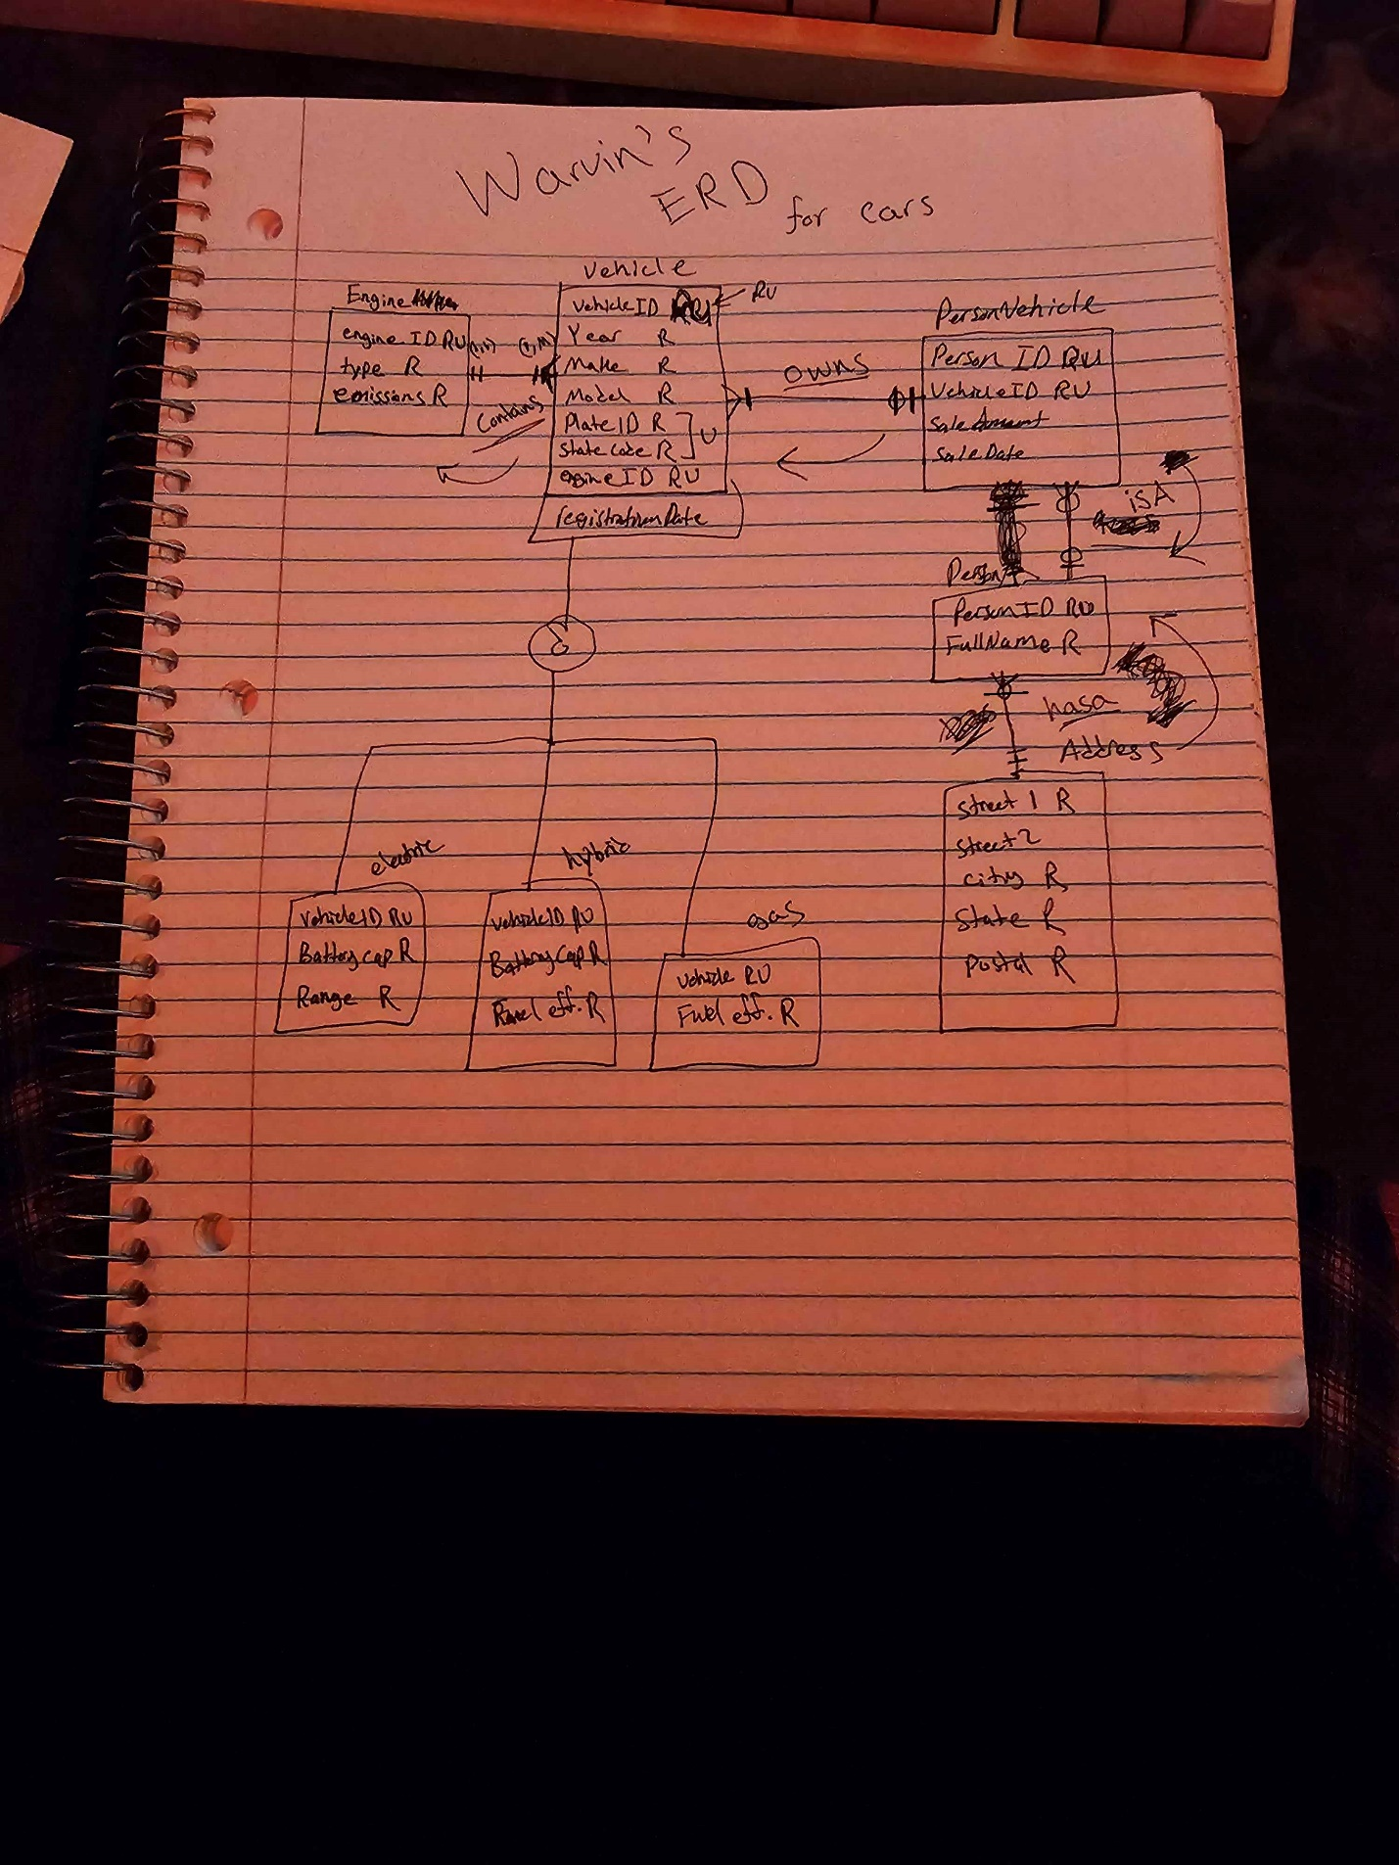

**2. Provide a Project Progress Report (15 points):**

**Have you obtained or generated all the data for your project?**

I have generated mock data using A.I. (ChatGPT) I believe this is satisfactory and has sufficient rows of data (100 entries).

Here is the mock data:



I used the following prompt:  
“I want 100 entries of raw data generated in the form of a csv file that mocks real data from 2015 until now. I want the columns to be based off of this schema: Owner information, such as fullname, and address(street1,street2optional,city,state,postal) Vehicle information such as year, make, model, plateID and Statecode, engine type and the emissions produced based off of miles driven (for electric I want emissions produced from production fossil fuels since they don't really produce anything on their own). As for the vehicle types (electric, hybrid, and gas) I want data on the battery capacity and range of electric types, battery capacity and fuel efficiency of hybrids and fuel efficiency of gas types. Also, some optional data meaning they don't all have to have data on these columns: registrationDate, salesAmount, salesDate.”

**Have you loaded any of the data into MySQL to work with?**

I have yet to load data into MYSQL (I’m still unsure how to and I might need to do some data cleaning). I plan to load this data by Friday, Nov. 22 when I hand in the outline slide for the final project.

**Have you performed any of the SQL queries you will need to perform to answer your proposed questions?**

I have yet to do this as well I plan to do this along with data once I figure out how exactly. Would I use the current server that we have for this class or do I make a local one? Here is an example instead of the question I could answer (Which car type produces the most CO2 emissions?) with the following query:

SELECT Year, Make, Model, CO2Emissions

FROM Vehicle

JOIN Engine ON Engine.EngineID = Vehicle.EngineID

ORDER BY CO2Emissions DESC;

This should output 4 columns and order by the highest CO2Emissions.